1. Make sure that the adapter that we attach to the computer has the ability to work on monitor or promiscuous mode.
2. Usually the built in laptop wireless adapter doesnot support monitor mode so check that first to see if monitor mode is supported. If not we will need to attach an external wireless adapter.
3. Use ip address command to check if the wlan appears. If it does then we know that they adapter is being read.
4. IWCONFIG to check if which mode the adapter is currently in .

managed : is normal mode

Monitor mode is what we want it to be in.

1. **Sudo airmon-ng check kill**

to check for any conflicting processes and kill them

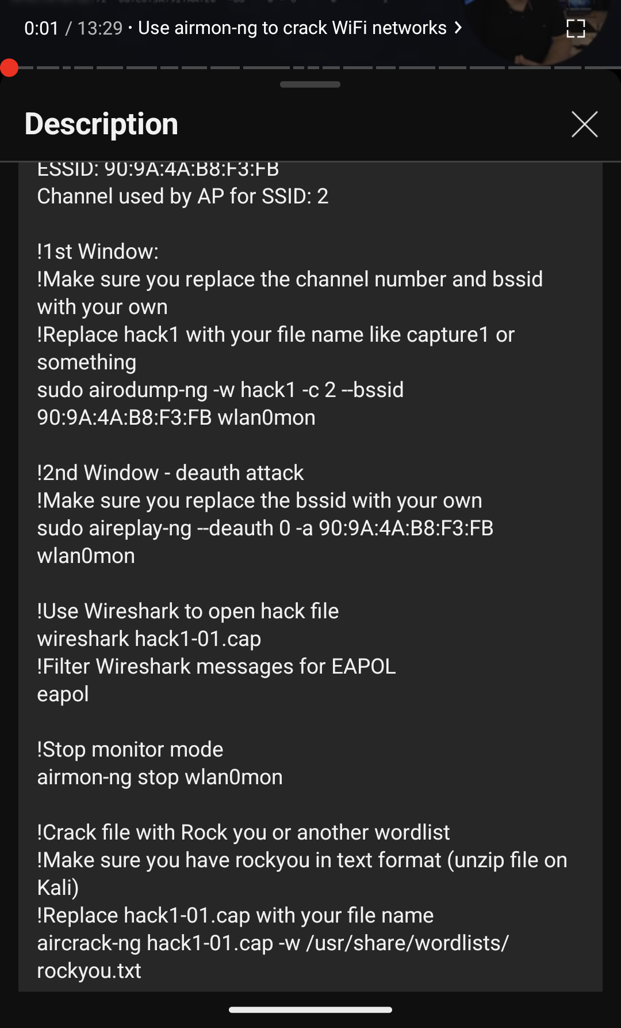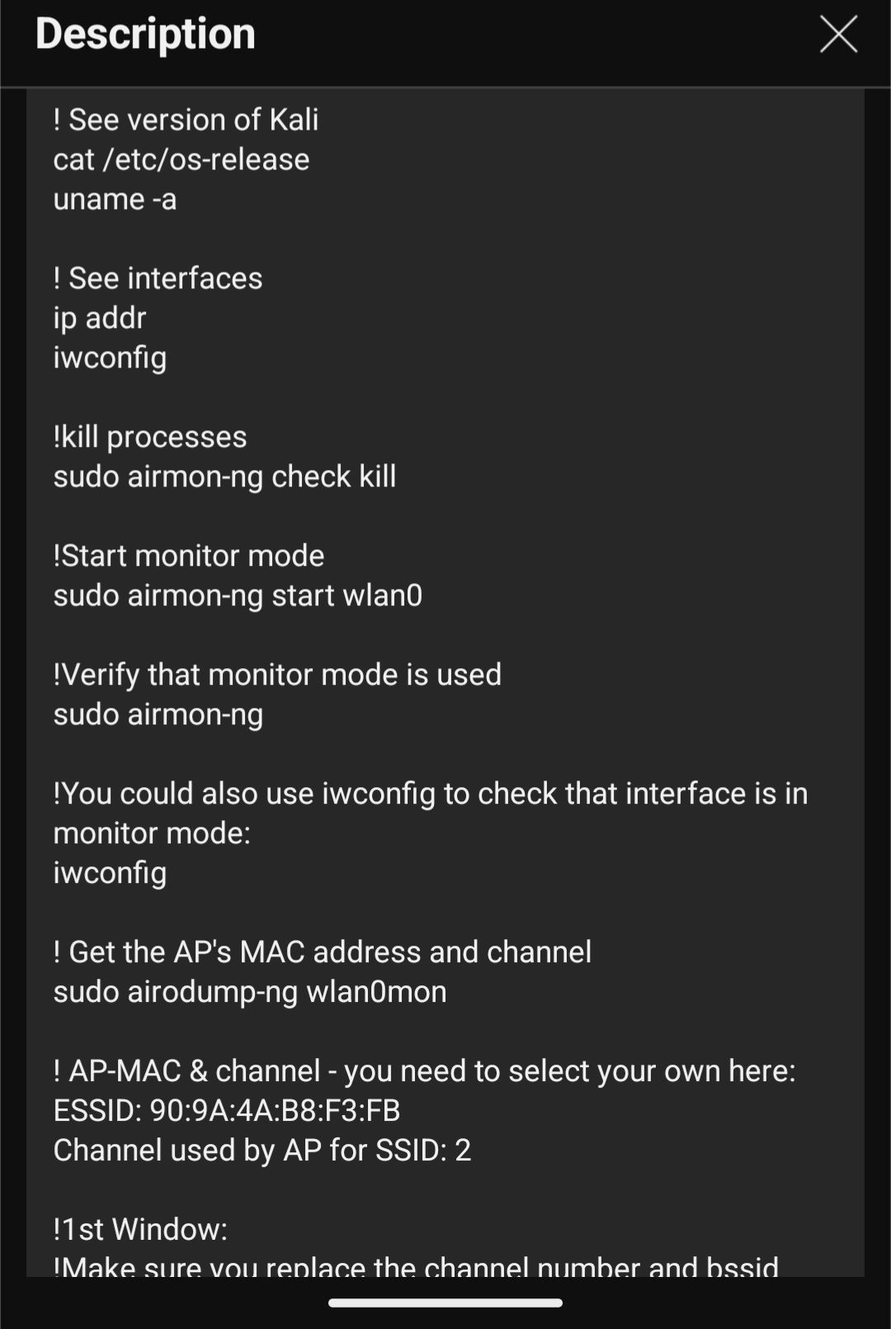

1. Start monitor mode